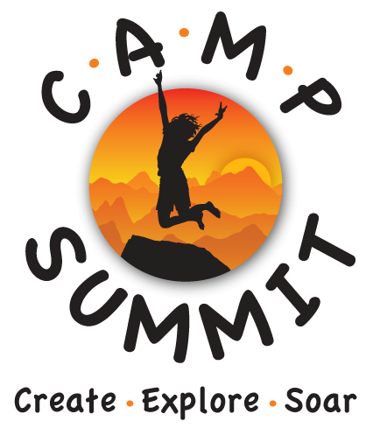

Media Release

Camp Summit will be posting photos/videos of our week at camp on a password protected website for your access. Also in future marketing or informational literature whether in print or electronic media we may incorporate photographs, video, writing, artwork and/or testimonials created during Camp Summit.

Camp Summit’s Media/Photo release form allows you to withhold consent for the release of your child’s name, photo or likeness in our publications or productions such as those listed. This includes:

- Newsletters
- Video productions or shorts
- Web sites
- Press releases
- Marketing Literature

Please complete and return this form along with their registration materials.

MEDIA RELEASE: 2015 Summer Camp

I GIVE PERMISSION for my child’s photograph, image, artwork, writing and/or testimonials to be used by Camp Summit, its member’s and those acting under its permission and on its authority.

Camper’s Name: (Print Clearly)__________________________________________________
First Middle Last

Parent/Guardian Signature: ___________________________ Date:__________________

Please Print Name ___________________________

