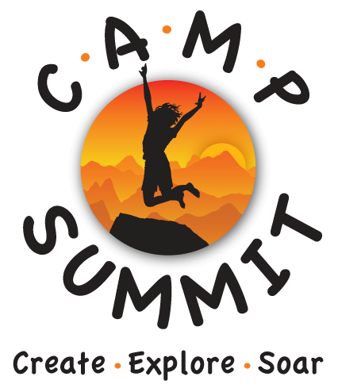

Acknowledgement and Assumption of Risks
Release and Indemnification

Definitions

I understand the term “Camp Summit” as used in this document means and includes Camp Summit for the Gifted, Talented and Creative, Inc. and each of their current and former officers, directors, employees, agents, contractors, and affiliated or related entities; the term “Camp Summit Staff” means and includes any employee or agent of Camp Summit; the term “I” means and includes any participant who is younger than 18 years of age; and the term “Program” means the Camp Summit program in which a participant has enrolled.

Acknowledgment and Assumption of Risks

I understand that during my participation in this Program, I may be exposed to a variety of risks and hazards, foreseen or unforeseen, which cannot be eliminated without fundamentally altering the unique character of the Program. These inherent risks include, but are not limited to, environmental risks and hazards, including rapidly moving, deep, or cold water; insects, snakes, and predators, including large animals; falling and rolling rock; lightning and unpredictable forces of nature, including weather that may change to extreme conditions without notice. Activities vary, and may include hiking, active games and initiatives, and stewardship activities. Possible injuries and illnesses include hypothermia, sunburn, heatstroke, dehydration, and other mild or serious conditions or injuries. Emergency evacuations and medical care may be delayed due to the remote location where activities take place.

I understand that this description of the risks involved is not complete, and that other unknown or unanticipated risks may result in property loss, injury, or death. As a condition of my participation in the Program, I agree to assume full responsibility for all the risks that such participation may entail. My participation in this Program is entirely voluntary, and I elect to participate with full knowledge of the inherent risks.

Consent to Medical Treatment

I understand that if I become ill or injured during the course of the program and am unable to give my consent to any medical treatment that a licensed physician and/or dentist deems necessary, Camp Summit will make a reasonable attempt to obtain consent for treatment from the Emergency Contact(s), that I have provided, before such treatment is commenced, unless my condition is such that treatment cannot be delayed for that purpose. If treatment cannot be delayed, then I hereby consent to such treatment as a licensed physician or dentist determines is necessary.

Release and Indemnification

In consideration of my participation in the Program and the services and amenities provided by Camp Summit, I VOLUNTARILY AGREE TO (1) RELEASE, DISCHARGE, AND HOLD HARMLESS CAMP SUMMIT, TO THE FULLEST EXTENT PERMITTED BY LAW FROM ANY AND ALL CLAIMS, DEMANDS, DAMAGES, LOSSES, OR LIABILITIES, INCLUDING, BUT NOT LIMITED TO, CLAIMS FOR PERSONAL INJURY OR DEATH, EVEN IF CAUSED BY THE NEGLIGENCE OF CAMP SUMMIT, ARISING OUT OF OR IN ANY WAY CONNECTED TO THE PROGRAM OR MY PARTICIPATION IN THE PREGRAM; and (2) indemnify and defend Camp Summit, to the fullest extent permitted by law, from and with respect to any and all claims, demands, liabilities, damages or costs, even if caused by the negligence of Camp Summit, arising out of or in any way connected with the Program, or my participation in the Program, or occurring during the inclusive dates of my attendance at the Program, and/or from any medical treatment I may receive during the Program.

Other Provisions

Camp Summit and persons designated by it may use my photograph, or any video, writing, artwork, and/or testimonial created by me and submitted to Camp Summit. It shall become the property of Camp Summit, and may be used by Camp Summit, at its discretion, for its own, marketing and/or development purposes, and I hereby consent to and authorize such use without restriction.

Agreement

- I have had the opportunity to ask Camp Summit any questions I may have about the Program in which I am enrolled, and any questions have been answered to my satisfaction.
- I understand that this document is intended by Camp Summit to have as broad an effect as the law of the document shall remain valid and fully enforceable.
- I have carefully read and I understand this entire document, and I am signing it voluntarily.
- I have the authority to sign this document for those listed below.

At least one parent (preferably both) or guardian must sign below if the camper is under 18 years of age to reflect their understanding and agreement, for themselves and on behalf of the camper, to the provisions of the definitions, acknowledgment and assumptions of risks, consent to medical treatment, release and indemnification, other provisions, and agreement.

Print Name of Adult/Parent(s)/Guardian(s)

1. _______________________________ 2. _______________________________

Signature of Adult/Parent(s)/Guardian(s)

1. ___________________________________________ Dated _____________________

2. ___________________________________________ Dated _____________________

Print Name of Participant(s) under age 18

- __________________________________________

2. __________________________________________

